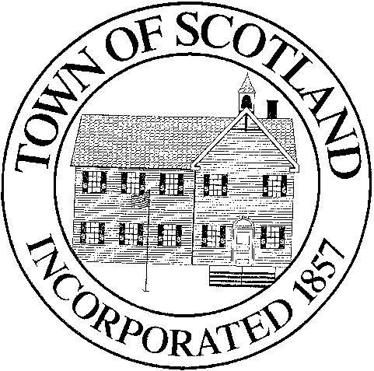
TOWN OF SCOTLAND
BOARD OF SELECTMEN

Scotland Town Hall 9 Devotion Road, P.O. Box 288 Scotland, CT 06264
(860) 456-7797 x 101

BOARD OF SELECTMEN MEETING
July 27th, 2022 – 7:00pm
Location: Scotland Volunteer Community Hall
47 Brook Road

Meeting is in-person, with online access

Please join my meeting from your computer, tablet or smartphone.
https://meet.goto.com/458872301
You can also dial in using your phone.
United States: +1 (786) 535-3211
Access Code: 458-872-301
Get the app now and be ready when your first meeting starts: https://meet.goto.com/install

AGENDA
- Call to Order
- Audience for Citizens
- Additions to Agenda
- Approval of minutes for the July 13th, 2022 BOS Meeting

- Treasurer’s Report
- Appointment of Kevin Benito to fill a vacancy on the Board of Assessment Appeals with the term ending on 11/21/2023

- Appointment of Barbara McKinney to Assistant Town Clerk and Assistant Registrar of Vital Statistics

- Report of Selectmen
- Audience for Citizens
- Adjournment
Action Anticipated on Agenda Items

